ADAPTIVE NETWORK SLICING IN NON-ORTHOGONAL MULTIPLE ACCESS (NOMA) LEVERAGING UNSUPERVISED LEARNING FOR TRAFFIC CLASSIFICATION AND RESOURCE MANAGEMENT: A REVIEW.
This research explores the integration of unsupervised machine learning techniques into adaptive network slicing within Non-Orthogonal Multiple Access (NOMA) systems to enhance traffic classification and resource management. As telecommunications networks evolve to support diverse services and applications, efficient resource allocation becomes critical. This study addresses the challenges of dynamic traffic environments by employing clustering and dimensionality reduction methods to analyze user behavior and traffic patterns without relying on labeled data. Through a comprehensive experimental framework, we demonstrate how unsupervised learning can identify hidden patterns in network traffic, leading to improved classification accuracy and more efficient resource distribution strategies. Our findings indicate that leveraging these techniques not only optimizes network performance but also enhances user experience by ensuring that quality of service requirements are met across varying conditions. This work contributes to the ongoing discourse on intelligent network management, providing a pathway for future research in adaptive resource allocation in next-generation mobile networks.

- INTRODUCTION
With the swift development of telecommunication networks, the demand for robust resource management methods capable of supporting diverse services and applications has surged. A notable solution to this challenge is network slicing, which facilitates the coexistence of multiple virtual networks on a single physical infrastructure, tailored to align with distinct service needs (Shah et-al., 2021). NOMA, or Non-Orthogonal Multiple Access, stands out as an essential innovation, permitting several users to access identical frequency resources concurrently. This advancement boosts spectral efficiency and expands the system's user capacity (DIng et-al., 2017).
As shown in figure 1.1, network systems grow more intricate, traditional methods for managing resources often struggle to respond to changing traffic patterns effectively. Unsupervised machine learning offers a robust alternative by employing algorithms that analyze unlabeled data to uncover patterns and structures. This approach significantly enhances traffic categorization and resource distribution within dynamic network slicing environments (Akbar et-al., 2021). Methods like clustering and dimensionality reduction, which fall under unsupervised learning, facilitate the examination of traffic trends and user behavior without requiring large labeled datasets. Their efficiency makes them ideal for real-time applications in constantly changing network scenarios (Rajasekaran & Yanikomeroglu, 2023).
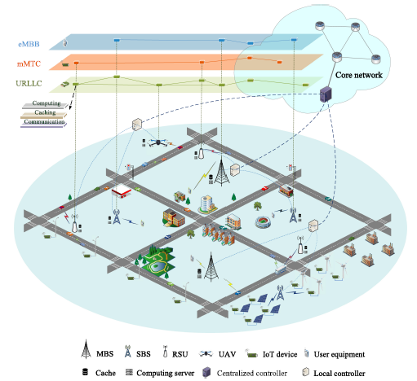
Figure: 1.1 An illustration of Network Slicing based on NGWN Architecture (Shen et-al., 2020).
The use of unsupervised learning within network slicing frameworks can substantially boost network efficiency. Clustering techniques, for instance, can classify traffic with similar characteristics, facilitating resource allocation that is better suited to the specific demands of each group (Domeke et-al., 2022). Dimensionality reduction techniques play a vital role in simplifying complex datasets, enhancing the ability to visualize and analyze traffic trends, a key factor in efficient resource management and decision-making processes (Domeke et-al., 2022).
Applying these methods helps optimize user satisfaction by maintaining quality of service (QoS) across different scenarios. As the need for fast and reliable connections grows, the ability to adjust network resources dynamically based on real-time traffic insights becomes more essential (Shu & Taleb, 2020).
MOTIVATION

Unsupervised machine learning (uML) techniques are pivotal for managing the immense volumes of unlabeled data produced by wireless communication networks in 5G and beyond. These approaches identify underlying patterns and structures without relying on predefined outcomes. Tasks such as clustering network traffic and user behavior are efficiently handled by uML, enabling better resource allocation and enhanced system performance. Furthermore, dimensionality reduction techniques simplify high-dimensional datasets, improving clarity and decision-making. By automating feature extraction, uML supports analyses where manual labeling is impractical and adapts effectively to real-time data, allowing dynamic network adjustments. This adaptability, combined with complementary machine learning methods, enables the creation of more advanced and efficient wireless communication technologies.

Aim and Objectives
Aim:
The aim of this research is to investigate the implementation of adaptive network slicing in Non-Orthogonal Multiple Access (NOMA) systems, utilizing unsupervised learning techniques for effective traffic classification and resource management to optimize network performance and user experience.

Objectives:
The above aim will be achieved through the following objectives
- To Review Existing Literature: Conduct a thorough review of current research on network slicing, NOMA, and unsupervised learning techniques to identify existing methodologies, challenges, and potential areas for improvement.
- To Analyze Traffic Patterns: Utilize unsupervised learning algorithms to analyze and classify traffic patterns in NOMA systems, aiming to identify distinct user behaviors and service requirements.
- To Develop an Adaptive Network Slicing Framework: Design and implement a framework for adaptive network slicing that can dynamically allocate resources based on traffic classification and user demands, enhancing overall network efficiency.
- To Simulate Network Scenarios: Create simulation models to evaluate the performance of the proposed adaptive network slicing framework under various traffic conditions and network topologies.
- To Evaluate Resource Management Strategies: Assess the effectiveness of different resource management strategies enabled by the adaptive slicing approach, focusing on metrics such as throughput, latency, and user satisfaction.
- To Validate the Framework with Real-World Data: Conduct experiments using real-world traffic data to validate the proposed framework's performance and its ability to adapt to changing network conditions.

- LITERATURE REVIEW

  - Orthogonal Multiple Access Technology
Orthogonal Multiple Access (OMA) is a communication technology that enables multiple users to share the same communication medium by allocating distinct resources to each user, thereby preventing interference among their signals. This technology is foundational in wireless communication systems, particularly in the context of 4G and 5G networks. OMA encompasses various methods, including Time Division Multiple Access (TDMA), Frequency Division Multiple Access (FDMA), and Code Division Multiple Access (CDMA), each designed to ensure that users can transmit data simultaneously without overlapping signals (DIng et-al., 2017). The development of OMA has been driven by the increasing demand for efficient spectrum utilization and the need for reliable communication in densely populated areas, where multiple users require simultaneous access to network resources (Shah et-al., 2021).
The key characteristics of OMA include its structured resource allocation, effective interference management, and relative simplicity in implementation. OMA systems allocate specific time slots, frequency bands, or codes to users, which allows for clear separation and minimizes the risk of interference (DIng et-al., 2017). This structured approach not only enhances the predictability of network performance but also simplifies the signal processing required at the receiver end. For instance, in TDMA, users take turns transmitting in their designated time slots, while in FDMA, each user operates on a unique frequency band. This clear delineation of resources makes OMA systems easier to manage and implement compared to more complex schemes like Non-Orthogonal Multiple Access (NOMA) (Dai et-al., 2018).
Despite its advantages, OMA has notable limitations that can hinder its effectiveness in modern communication environments. One significant drawback is the inefficient utilization of resources, particularly in scenarios where user traffic demands vary widely. If a user is inactive, their allocated resources remain unused, leading to potential waste of valuable spectrum (Shah et-al., 2021). Additionally, as the number of users increases, the fixed allocation of resources can limit the scalability of OMA systems, making it challenging to accommodate the growing demand for mobile data, especially in urban areas with high user density. These limitations highlight the need for more flexible and efficient access technologies as the telecommunications landscape continues to evolve (Liu et-al., 2024).
  - Non-Orthogonal Multiple Access Technology
Non-Orthogonal Multiple Access (NOMA) is an advanced communication technology designed to enhance the capacity and efficiency of wireless networks by allowing multiple users to share the same time and frequency resources simultaneously. Unlike traditional Orthogonal Multiple Access (OMA) methods, which allocate distinct resources to each user to avoid interference, NOMA employs power-domain multiplexing to differentiate users based on their channel conditions. This means that users with better channel conditions can transmit at lower power levels, while those with poorer conditions transmit at higher power levels, enabling simultaneous transmission without interference (DIng et-al., 2017). The emergence of NOMA is largely driven by the increasing demand for higher data rates and the need to accommodate a growing number of users in next-generation networks, particularly in the context of 5G and beyond(Akbar et-al., 2021)
The key characteristics of NOMA include its ability to significantly improve spectral efficiency, enhance user capacity, and provide better service to users with varying channel conditions. By allowing multiple users to transmit simultaneously over the same frequency band, NOMA can accommodate a larger number of users compared to OMA, which is limited by its fixed resource allocation (Liu et-al., 2024). Additionally, NOMA employs advanced signal processing techniques, such as Successive Interference Cancellation (SIC), to decode the superimposed signals at the receiver, which further enhances its performance (Dai et-al., 2018). This capability makes NOMA particularly suitable for scenarios with high user density, such as urban environments, where efficient resource utilization is critical (Ebrahimi et-al., 2020).
Promising solutions for implementing NOMA in 5G and beyond include the integration of machine learning techniques for dynamic resource allocation and user pairing, which can optimize performance based on real-time traffic condition (Akbar et-al., 2021). Furthermore, the combination of NOMA with other emerging technologies, such as Massive MIMO and millimeter-wave communications, can further enhance its effectiveness by leveraging the advantages of these technologies to improve overall network performance (Makki et-al., 2020). Additionally, research into hybrid NOMA schemes, which combine both power and code domain multiplexing, is being explored to address the challenges of interference management and to enhance the flexibility of resource allocation in future wireless networks. These innovations position NOMA as a key enabler for the next generation of wireless communication systems, addressing the increasing demands for capacity and efficiency (Makki et-al., 2020).
  - Description of the Network Slicing Architecture in NOMA
Network slicing architecture in Non-Orthogonal Multiple Access (NOMA) is a significant advancement in the design of 5G networks, facilitating the efficient allocation of resources to accommodate diverse user demands and application requirements. This architecture allows multiple virtual networks to operate on a single physical infrastructure, each tailored to specific service needs. The integration of NOMA with network slicing enhances the ability to support a wide range of applications, from massive machine-type communications to ultra-reliable low-latency communications, by enabling multiple users to share the same frequency resources simultaneously without interference (Architecture, 2023).
The architecture consists of several essential components. The slice management layer oversees the lifecycle of network slices, including their creation, modification, and deletion based on real-time traffic demands and service level agreements (SLAs). This layer ensures that each slice can dynamically adapt to changing conditions, providing the necessary resources to meet diverse user requirements effectively (Habibi et-al., 2022). The resource allocation layer is crucial for distributing resources among different slices. By employing advanced algorithms, this layer optimizes resource allocation based on user priority, channel conditions, and traffic patterns, which is essential for leveraging the advantages of NOMA (Shahab et-al., 2020).
The ITU and 3GPP have outlined three key network usage scenarios to address the wide range of connected devices and their unique QoS demands. These include enhanced mobile broadband (eMBB), massive machine-type communications (mMTC), and ultra-reliable low-latency communications (URLLC). eMBB typically supports human-type or human-to-human communications, characterized by a smaller number of devices, a strong focus on downlink traffic, and larger data volumes per device. Conversely, mMTC and URLLC are designed for IoT applications and exhibit characteristics that differ markedly from those of HTC (Shahab et al., 2020).
Furthermore, the control and orchestration layer integrates various network functions and manages interactions between different slices. This layer is vital for maintaining quality of service (QoS) across slices, particularly in a NOMA environment where multiple users share resources. Machine learning techniques can be utilized in this layer to predict traffic patterns and proactively adjust resource allocation, enhancing the overall efficiency of the network slicing architecture (Shahab et-al., 2020). Finally, the user equipment (UE) layer interacts directly with the network slices, allowing users to access services tailored to their specific needs. Advanced user-centric protocols facilitate seamless connectivity and optimal performance, ensuring that users benefit from the tailored services provided by the network slices (Iswarya & Jayashree, 2021).
The combination of NOMA and network slicing presents promising solutions for addressing the diverse requirements of 5G and beyond. By enabling efficient resource management and tailored service delivery, this architecture not only enhances user experience but also maximizes the utilization of network resources, paving the way for more flexible and scalable wireless communication systems (Basharat et-al., 2018).
- CLASSIFICATION OF MACHINE LEARNING
The process of learning generally encompasses acquiring or adapting behaviors, values, knowledge, abilities, or preferences. Theories like Behaviorism, Cognitivism, Constructivism, Experientialism, and Social Learning explain the methods humans use to understand and apply new information. In contrast to humans, who naturally learn from their experiences, machines require data as the foundation for learning and decision-making (Alzubi et-al., 2018). Arthur Samuel described machine learning as the discipline that empowers computers to acquire knowledge and skills without direct programming. Known for his pioneering work in creating a checkers-playing program, Samuel's contributions laid a foundation for the field. ML aims to train machines to manage and analyze data with greater efficiency. In many cases, understanding or extracting valuable insights from raw data can prove difficult without such techniques (Mahesh, 2020). The telecom industry is primed for the integration of machine learning techniques. Operators handle extensive datasets, such as customer details, web performance records, Internet traffic analytics, and data from social media platforms (Zhebka et-al., 2022). The discipline that uses machine learning is shown in figure 2.1 below.
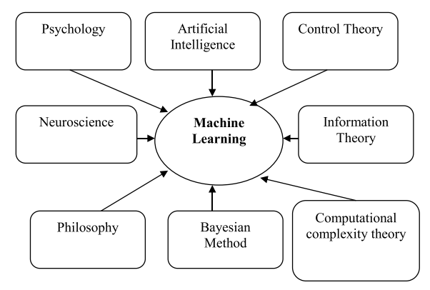
Figure: 2.1 Machine Learning Multi-discipline (Alzubi et-al., 2018).

Next-Generation Wireless Networks (NGWNs) possess diverse and constantly evolving characteristics, requiring advanced tools to automate and enhance network slicing processes. Research indicates that machine learning (ML) holds significant promise in addressing these needs. Leveraging ML in network slicing can drive innovations to overcome architectural and resource management challenges, thereby supporting the vision and capabilities of NGWNs (Shen et-al., 2020). The classification of machine learning is shown in figure 2.2 below.
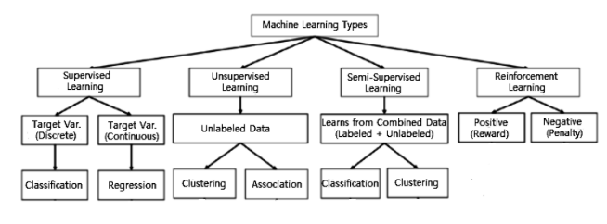
Figure: 2.2 Machine Learning Classification (Sarker, 2021).

- Supervised Learning
In machine learning, supervised learning is the process of training a model to associate inputs with corresponding outputs using labeled data. As shown in figure 2.3, this method involves utilizing datasets with predefined input-output examples to develop a predictive function. It follows a goal-oriented approach, where specific outcomes are targeted based on the input data provided (Sarker, 2021).
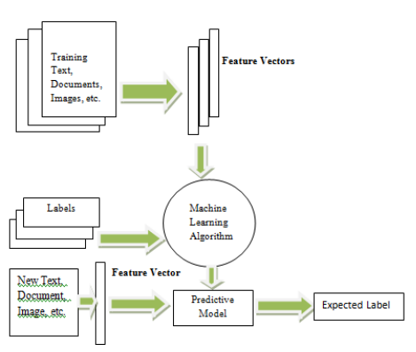
Figure: 2.3 Supervised Learning (Alzubi et-al., 2018).
- Un supervised Learning
Unsupervised learning algorithms are pivotal in data analysis, particularly for identifying patterns and structures in unlabeled datasets. Two primary categories of unsupervised algorithms are clustering and dimensionality reduction. Clustering algorithms, such as K-means, hierarchical clustering, and DBSCAN, are designed to group data points based on their similarities, allowing for the identification of inherent structures within the data. K-means clustering, for instance, partitions data into K distinct clusters by minimizing the variance within each cluster, making it effective for applications like customer segmentation and image recognition (MacQueen, 1967). Hierarchical clustering builds a tree of clusters, which can be useful for understanding the relationships between different data points at various levels of granularity (Müllner, 2013).
Dimensionality reduction techniques, such as Principal Component Analysis (PCA) and t-Distributed Stochastic Neighbor Embedding (t-SNE), are employed to reduce the number of features in a dataset while preserving its essential characteristics. PCA transforms the data into a new coordinate system, where the greatest variance by any projection lies on the first coordinate (Jolliffe, 2002). This method is particularly useful in preprocessing data for supervised learning tasks, as it helps to mitigate the curse of dimensionality and improve model performance. t-SNE, in contrast, is particularly effective for visualizing high-dimensional data by converting similarities between data points into joint probabilities, allowing for the representation of complex datasets in two or three dimensions (Van der Maaten & Hinton, 2008).
The choice of unsupervised learning methods is often justified by the nature of the data and the specific objectives of the analysis. For exploratory data analysis, clustering provides insights into the underlying structure of the data, which can inform further analysis or hypothesis generation (Kaufman & Rousseeuw, 2009). Dimensionality reduction is justified when dealing with high-dimensional data, as it simplifies the dataset while retaining its most informative features, facilitating better visualization and interpretation (Bishop, 2006). Moreover, these methods are particularly valuable in scenarios where labeled data is scarce or unavailable, making them indispensable in fields such as bioinformatics, image processing, and market research (Xia et-al., 2015).
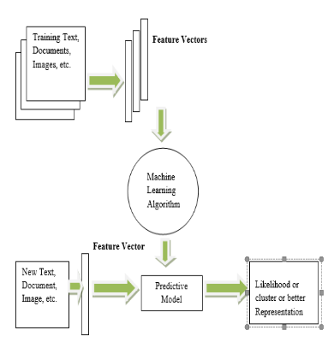
Figure: 2.4 Unsupervised Machine Learning (Alzubi et-al., 2018).
- Unsupervised Machine Learning Algorithms used for Network Slicing
Unsupervised machine learning methods, such as K-means, clustering algorithms, and genetic approaches, operate on unlabeled data without predefined results. These models work by uncovering inherent structures in the input data and deriving overarching rules or patterns. This can involve mathematical procedures to reduce redundancy or organizing the data based on shared characteristics. The ultimate aim is to reveal data groupings or patterns that offer valuable insights (Rae et al., 2014).
- K-means Algorithm
The K-means algorithm is a common unsupervised machine learning technique for grouping data. Its objective is to segregate 'n' data points into 'k' clusters, ensuring each point belongs to the cluster whose average value is nearest to it. The cluster's center, represented by the average of its data points, acts as its defining feature (Alzubi et al., 2018). Figure 2.5 shows before and after clustering process of k-mean clustering algorithm. The Pseudo code used for k-mean clustering algorithm is indicated in figure 2.6 below.
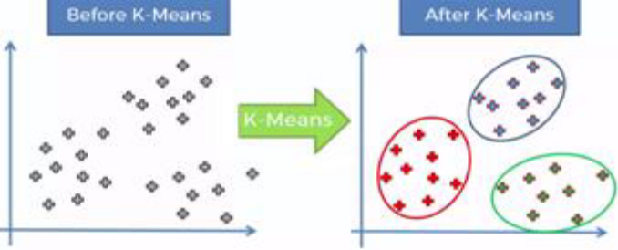
Figure: 2.5 K-mean clustering before and after clustering
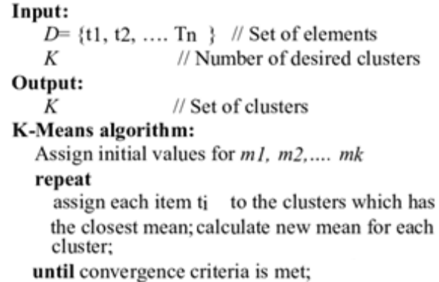
Figure: 2.6 K-means clustering Pseudo code
- Principal Component Analysis (PCA)
Principal Component Analysis (PCA), a popular multivariate statistical method, serves as a tool for analyzing the relationships among numerous variables. By reducing the number of variables, PCA makes computations faster and more efficient. As indicated in figure 2.7, PCA organizes variables into smaller groups, termed components or factors, based on their interconnections. These components are then used to extract critical dimensions, which assist in classifying the population into uniform groups (Dash et al., 2021).
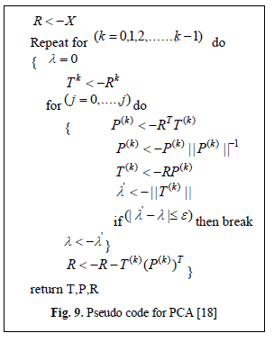
Figure: 2.7 Pseudo code for PCA
- Anomaly Detection
In data mining, anomaly detection focuses on recognizing irregularities within a dataset, which may include outliers, noise, deviations, novelties, or exceptions. This technique identifies elements, events, or observations that diverge from established patterns or typical characteristics found in the data (Dike et al., 2018).
In intrusion detection (ID), data mining techniques are used to automatically detect, extract, and differentiate between normal and invasive patterns. Data mining (DM) issues typically fall into one of four categories: classification, clustering, regression, or association rule learning. A key step in the intrusion detection system (IDS) process is the feature selection (FS) technique, which identifies important features and discards unnecessary ones to avoid performance decline (Saeed et al., 2023).

III. MATERIALS AND METHODS
In this section, the materials to be used as well as the methods to Adopt in the realization of this work will be discussed.
- MATERIALS
The materials to be used for the realization of this work are:
- Notebook Computer W76c.
- Python-based libraries to create NOMA network scenarios.
- METHODOLOGY
The proposed methodology to be adopted in this research work are as follows:
- To conduct a thorough literature survey on network slicing in non-orthogonal multiple access which involves the following steps:
- Literature survey on OMA and NOMA technology and its challenges.
- Network slicing techniques and their implementation in 5G and beyond.
- The application of k-means clustering in wireless networks for tasks such as user grouping, resource optimization, or traffic analysis.
- Design a network slicing framework for NOMA which involves following these steps:
- Obtain real-world traffic datasets from telecommunications providers or research projects focusing on NOMA. Ensure proper anonymization and ethical considerations for real-world data.
- Apply clustering algorithms (e.g., K-means, DBSCAN, hierarchical clustering) to group users based on traffic similarity, QoS requirements, or channel conditions.
- Experiment with different values of k (number of clusters) and validate using spectral efficiency, fairness index, latency and energy efficiency as performance metrics.
- Define slices based on use cases eMBB, URLLC, mMTC considering constraints like latency, throughput, or reliability.
- Hybrid Unsupervised Learning with Anomaly Detection
- Combine clustering (K-means) with anomaly detection techniques to classify normal vs. irregular traffic patterns.
- Allocate resources adaptively, ensuring anomalies (e.g., sudden traffic spikes or malicious activity) are isolated and handled separately.
- Implement genetic algorithms or reinforcement learning to fine-tune resource distribution across slices.
- Validate using simulation models and real-world traffic datasets.
- Result validation which adopts the steps below:
- Visualize the clustering results using scatter plots, heat maps and 3D projections.
- Interpret how clustering impacts network slicing and resource allocation in NOMA.
- Discuss observed trade-offs and limitations.
- CONCLUSION
This proposal details a thorough approach to optimizing 5G network slicing by integrating machine learning and deep learning techniques. The research focuses on a hybrid model that uses optimal weighted feature extraction and advanced classification methods to enhance the accuracy and efficiency of network resource allocation. The expected results include improved Quality of Service (QoS) for various applications, effective management of increasing data traffic, and the ability to dynamically adapt to varying user demands. As the demand for reliable and high-performance 5G services grows, this research will provide valuable insights and methodologies for real-world application, advancing the field of network slicing and supporting the evolution of 5G networks. We believe the findings from this study will pave the way for future innovations in network management, ensuring that 5G technologies can meet the diverse and complex needs of emerging applications and industries.

REFERENCES
Akbar, A., Jangsher, S., & Bhatti, F. A. (2021). NOMA and 5G emerging technologies: A survey on issues and solution techniques. Computer Networks, 190(February), 107950. https://doi.org/10.1016/j.comnet.2021.107950
Alzubi, J., Nayyar, A., & Kumar, A. (2018). Machine Learning from Theory to Algorithms: An Overview. Journal of Physics: Conference Series, 1142(1), 1–16. https://doi.org/10.1088/1742-6596/1142/1/012012
Architecture, B. B. G. (2023). Intelligent Congestion Control In Internet of Vehicles ( IoV ) employing Network Slicing in.
Basharat, M., Ejaz, W., Naeem, M., Khattak, A. M., & Anpalagan, A. (2018). A survey and taxonomy on nonorthogonal multiple-access schemes for 5G networks. Transactions on Emerging Telecommunications Technologies, 29(1), 1–17. https://doi.org/10.1002/ett.3202
Dai, L., Wang, B., Ding, Z., Wang, Z., Chen, S., & Hanzo, L. (2018). A survey of non-orthogonal multiple access for 5G. IEEE Communications Surveys and Tutorials, 20(3), 2294–2323. https://doi.org/10.1109/COMST.2018.2835558
Dash, S. S., Nayak, S. K., & Mishra, D. (2021). A review on machine learning algorithms. Smart Innovation, Systems and Technologies, 153(October), 495–507. https://doi.org/10.1007/978-981-15-6202-0_51
Dike, H. U., Zhou, Y., Deveerasetty, K. K., & Wu, Q. (2018). Unsupervised Learning Based On Artificial Neural Network: A Review. 2018 IEEE International Conference on Cyborg and Bionic Systems, CBS 2018, October, 322–327. https://doi.org/10.1109/CBS.2018.8612259
DIng, Z., Lei, X., Karagiannidis, G. K., Schober, R., Yuan, J., & Bhargava, V. K. (2017). A Survey on Non-Orthogonal Multiple Access for 5G Networks: Research Challenges and Future Trends. IEEE Journal on Selected Areas in Communications, 35(10), 2181–2195. https://doi.org/10.1109/JSAC.2017.2725519
Domeke, A., Cimoli, B., & Monroy, I. T. (2022). Integration of Network Slicing and Machine Learning into Edge Networks for Low-Latency Services in 5G and beyond Systems. Applied Sciences (Switzerland), 12(13), 1–22. https://doi.org/10.3390/app12136617
Ebrahimi, S., Zakeri, A., Akbari, B., & Mokari, N. (2020). Joint Resource and Admission Management for Slice-enabled Networks.
Habibi, M. A., Yousaf, F. Z., & Schotten, H. D. (2022). Mapping the VNFs and VLs of a RAN Slice Onto Intelligent PoPs in Beyond 5G Mobile Networks. IEEE Open Journal of the Communications Society, 3(March), 670–704. https://doi.org/10.1109/OJCOMS.2022.3165000
Iswarya, N., & Jayashree, L. S. (2021). A Survey on Successive Interference Cancellation Schemes in Non-Orthogonal Multiple Access for Future Radio Access. Wireless Personal Communications, 120(2), 1057–1078. https://doi.org/10.1007/s11277-021-08504-1
Liu, Y., Ouyang, C., Ding, Z., & Schober, R. (2024). The Road to Next-Generation Multiple Access: A 50-Year Tutorial Review. 1–46. https://doi.org/10.1109/JPROC.2024.3476675
Mahesh, B. (2020). Machine Learning Algorithms - A Review. International Journal of Science and Research (IJSR), 9(1), 381–386. https://doi.org/10.21275/art20203995
Makki, B., Chitti, K., Behravan, A., & Alouini, M. S. (2020). A survey of noma: Current status and open research challenges. IEEE Open Journal of the Communications Society, 1(December 2019), 179–189. https://doi.org/10.1109/OJCOMS.2020.2969899
Rae, I., Kaur, S., & Jindal, S. (2014). I nter national Journal of I nnovative Resear ch in Advanced Engineering ( I JI RAE). 3(November), 6–14. www.ijirae.com
Rajasekaran, A. S., & Yanikomeroglu, H. (2023). Neural Network Aided User Clustering in mmWave-NOMA Systems With User Decoding Capability Constraints. IEEE Access, 11(May), 45672–45687. https://doi.org/10.1109/ACCESS.2023.3274556
Saeed, M. M., Saeed, R. A., Abdelhaq, M., Alsaqour, R., Hasan, M. K., & Mokhtar, R. A. (2023). Anomaly Detection in 6G Networks Using Machine Learning Methods. Electronics (Switzerland), 12(15). https://doi.org/10.3390/electronics12153300
Sarker, I. H. (2021). Machine Learning: Algorithms, Real-World Applications and Research Directions. SN Computer Science, 2(3), 1–21. https://doi.org/10.1007/s42979-021-00592-x
Shah, A. F. M. S., Qasim, A. N., Karabulut, M. A., Ilhan, H., & Islam, M. B. (2021). Survey and performance evaluation of multiple access schemes for next-generation wireless communication systems. IEEE Access, 9, 113428–113442. https://doi.org/10.1109/ACCESS.2021.3104509
Shahab, M. B., Abbas, R., Shirvanimoghaddam, M., & Johnson, S. J. (2020). Grant-Free Non-Orthogonal Multiple Access for IoT: A Survey. IEEE Communications Surveys and Tutorials, 22(3), 1805–1838. https://doi.org/10.1109/COMST.2020.2996032
Shen, X., Gao, J., Wu, W., Lyu, K., Li, M., Zhuang, W., Li, X., & Rao, J. (2020). AI-assisted network-slicing based next-generation wireless networks. IEEE Open Journal of Vehicular Technology, 1(November 2019), 45–66. https://doi.org/10.1109/OJVT.2020.2965100
Shu, Z., & Taleb, T. (2020). A novel QoS framework for network slicing in 5G and beyond networks based on SDN and NFV. 34(3), 256–263. https://doi.org/10.1109/MNET.001.1900423
Zhebka, V., Gertsiuk, M., Sokolov, V., Malinov, V., & Sablina, M. (2022). Optimization of Machine Learning Method to Improve the Management Efficiency of Heterogeneous Telecommunication Network. CEUR Workshop Proceedings, 3288, 149–155.

